Health and Safety Risks in Hop-Picking Activities: An Analysis of the State of the Art

Giovanni Matranga^{1(🖂)}, Niccolò Pampuro¹, Federica Caffaro²,
Lucia Vigoroso¹, and Eugenio Cavallo¹

¹ Institute of Sciences and Technologies for Sustainable Energy and Mobility (STEMS), National Research Council of Italy (CNR), Strada delle cacce, 73,
10135 Turin, Italy

giovanni.matranga@stems.cnr.it

² Department of Education, University of Roma Tre, Via del Castro Pretorio, 20 – 00185 Rome, Italy

Abstract. In the last decade, hop cultivation has seen greater interest in small and medium-sized farms due to the rising importance of craft beer micro-breweries requiring local raw materials. However, high investments are needed for mechanized harvesters. Small-scale farms cannot face these costs; thus, manual harvesting of hop cones is frequently adopted. The study investigated the risks for the health and safety of operators during manual and mechanized harvesting, also examining musculoskeletal disorders the workers can incur. A literature review and secondary data analysis investigated risk factors associated with the manual and mechanized harvesting process. Furthermore, the operator’s workload related to the hop cones picking time was analyzed based on international standards. The results showed that operators face several critical issues during the different tasks of the manual harvesting of hops. Some of the operations are carried out at height with the risk of falling and assuming bad postures that can pose risks to the operator’s health. Furthermore, the study points out major health concerns for the workers because of the repetitiveness of the operations they have to carry out. The mechanization of harvesting involves a significant increase in efficiency by reducing the number of operators involved. This results in an improvement in operators’ health conditions. However, the harvesting equipment can represent a safety risk for the operators because of their interaction with the moving parts of the machinery.

Keywords: Hop, Mechanized harvesting, Manual picking, Musculoskeletal disorders, Occupational safety

1 Introduction
In the last two decades, the beer industry has experienced substantial market worldwide growth, recording +36% [1] globally in beer productions. This trend caused major requests in hop production and consequently incremented cultivated areas, especially in Centre-East Europe and the US, where hop cultivation is historically grounded. The Italian brewing industry is recording significant growth (+39%) due to a new trend in the brewing compartment: the craft beer industry [2]. By its legal definition, in Italy, craft beer is produced by small breweries, or microbreweries, able to produce volumes not exceeding 200.000 hectoliters per year. National craft brewing is still being addicted to imported hop: only 1.2% of hop implemented in the Italian brew industry is local, corresponding to about 41 ha of cultivated areas, mainly distributed in the north (ISTAT 2019). In regions where hop cultivation is not traditionally implemented, small-scale farms are commonly the first to tempt new cultivations. For example, the hop cultivated area for each farm in Italy amounts to around 0, 4 ha [3]. However, small-scale cultivation does not allow to justify investments to realize mechanized systems all along with the growing and harvesting cycles. Therefore, small-scale farms usually cope manually with almost the entire production cycle, especially harvest operations.

Hop harvesting time is the most intense of the entire production cycle. A proper harvest has a positive impact on the quality of the final product [4]. Hop cones must be collected, cleaned from the vegetal residue, and dried as fast as possible to ensure high-quality and sanitary standards [5]. Manual hop-picking operations require long times, repetitive gestures, and assuming awkward postures that can expose workers to health risks, especially upper limbs overload.

Different previous studies showed that the agricultural sector causes many health threats due to ergonomic and accidental risks [6-8]. The present study investigates the risks for the health and safety of operators during manual harvesting, examining the possible risks of work-related musculoskeletal disorders (WMSDs) due to static postures, low loads at high frequencies related to manual harvesting of hop florescence, comparing them to the possible health and safety risks related to the worker-machine interaction (hop-picking machines, specifically) in mechanized harvesting. International standards most suitable for risk assessment in hop-picking activities were also identified. The study intends to fill the gap in the literature around this theme, defining state-of-the-art occupational risks in hop-picking activities and putting the ground for future research, with the final aim to identify areas for possible interventions in terms of machinery re-design and training to promote operators’ health and safety.

2 Methods
The study was articulated in three parts. The first step consisted of reviewing the literature about each hop harvest method, comparing manual and mechanized operations. Literature about manual and mechanized hop-picking solutions has been revised through a targeted search on scientific journals databases, such as Science Direct, Scopus, and Web of Science. A keyword-based search was used to identify articles, using the following keywords: hop harvest* OR hop-picking AND manual activit* OR manual operation* OR mechanized OR machine*. Specialized magazines and corporate websites were consulted as well. In the second step, an analysis of potential safety risks during all harvesting processes was made to highlight the critical issues. After-wards, literature on risk assessment and prevention of work-related health and safety risks was reviewed, especially regarding static and awkward postures, low loads manual handling, and repetitive operations. Eventually, because there is no specific literature on the health risks related to hop harvest, an analysis of existing international standards assessing biomechanical overload and risks in human–machine interaction was performed.

3 Results

3.1 Hop Harvesting Methods
The Hop harvesting period corresponds with the inflorescence ripening, when a rich complex of resins and essential oils accumulate inside flower glands. As shown in studies, both in central Europe [4] and North America [9], ripening is gradual and generally begins in late July and ends in early September. In these regions, mature cones are collected from mid-August to September. Accurate harvest timing is crucial to get a high-quality product since it significantly influences the final aroma [4].

Hop harvest can be realized through different solutions, partly depending on the territorial context:

- Infield manual picking of hop cones. The inflorescences are directly collected from bines by workers through ladders or trailers with elevators [10].

- Bines cutting and loading on trailers, and cones picking is carried out later by operators. Bines cutting can be arranged manually (Fig. 1) or through specific cutting mechanized systems [11].

- Cutting and loading mechanized of the bines, transport in shed and load in the hop-picking machines [12].

Manual hop harvesting is the low-tech solution; it consists of manual cutting of bines and manual picking of cones, directly in the field or operating out of the field, from previously harvested bines. The bines manual harvest involves cutting the stem below and then above using shears or sickles, implying elevators and adopting, in some conditions, awkward postures. The time–frequency of such postures depends on the number of workers and harvested area. The hop picking consists of manually collecting cones, thus it can be operated directly in the field through ladders or elevators or collected out of the field, from harvested bines.

The mechanized hop harvesting consists firstly of a bine cutter to collect the stems loaded on a trailer and secondly in a hop picker. There are many types of bine cutter and loader; most of them are devices adjustable into the tractor via the Power Take-Off (PTO) [13]. The hop picking machine sepa-rates hop cones from the stem and the cleaning process to eliminate residues. Its primary energy source is electricity, and typically is located in a shed area. The machine size, the workload and the number of workers depend on the number of bines to process, hence by the harvested area and the hop variety [14].

3.2 Critical Issues in the Hop Harvest
Manual harvesting solutions are associated with some critical issues that could pose health risks: hop cones collection implies working at height, through the use of ladders or elevators, assuming static and dynamic postures by the bines cutting and loading efforts, and operating at high time frequencies for an extended period, due to the amount of handwork [15].

On the other hand, mechanized hop collecting provides more harvest efficiency and reduces manual efforts and their negative consequences for the operator. Nonetheless, human–machine interaction could cause many safety risks if the safety provisions are not assured or observed [16].

Furthermore, few studies have been published on occupational diseases during hop harvest and processing because of hop dust contact or inhalation [17, 18]. Reeb-Whitaker and Bonauto [18] reported that respiratory work diseases in hop cultivation are 30 times greater than the rate of respiratory illnesses diagnosed in open field vegetable crop farms. Principal diagnoses associated with exposure to hop dust are asthma and other respiratory disorders related to bronchial allergy, mainly observed in harvest activities and post-harvest processing.

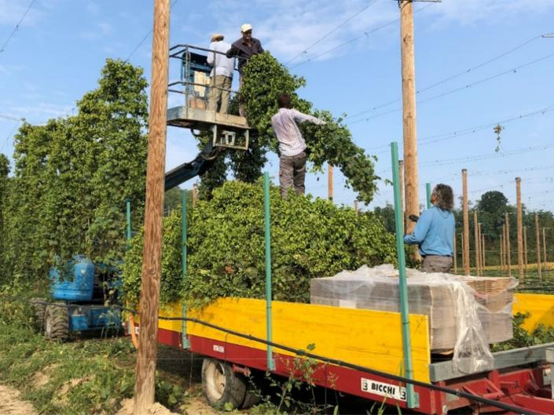

Fig. 1. Hop harvest activities in northern Italy: manual bines cutting and loading into a trailer.

3.3 Assessment and Prevention of Work-Related Health and Safety Risks
International standardization bodies have substantially contributed to promoting work related health by providing standards to control and prevent potential MSDs. Specifically, for the risk assessment related to inadequate static postures adopted throughout the harvest activities, we can refer to the ISO 11226: 2019 “Evaluation of Static Working Postures” [19], which defines as a static posture any posture that holds the position for at least 4 s, considering minor variations. This international standard establishes the limits for static working postures, examining externally applied force, body angles and time [20]. It gives recommendations concerning work modalities that guarantee sufficient physical and mental variations. The valuation procedure is used to determine the acceptability of work postures, considering body segments and joints in one or two control tiers. Tier one considers only body angles, analyzing risks due to ligaments, cartilages and intervertebral discs. The evaluation can lead to an acceptable, unrecommended activity. The assessment continues to tier two, where different variables should be considered, such as the holding time of specific body angles.

The ISO 11228-3:2009 “Handling of low loads at high frequency” [21] is another standard that could be suitable to assess the risks associated with specific activities related to manual and mechanical harvesting. It belongs to the ISO 11228 series, which also deals with lifting and transport operations and pushing and pulling of loads. ISO 11228-3:2009 includes a risk assessment concerning handling low loads in repetitive tasks, leading to biomechanical overload pathologies involving the osteoarticular, musculotendinous, and nerve-vascular structures. In addition, the upper limbs stress can cause pain and fatigue, leading to musculoskeletal disorders, reduced productivity, and deteriorated postures and movement coordination. The risk assessment procedure consists of hazard identification, which accounts for frequent repetitive movements, complex postures and combined movements, use of force, duration and insufficient recovery, vibration and impact forces, environmental conditions as the presence of noise or non-optimal climate. Each potential risk factor is evaluated by a checklist, which allows for the classification of the risk by the three-zone model (“no risk”, “very low risk” and “risk”) and determines the consequences to be acted upon. Additionally, the standard provides the Occupational repetitive action index (OCRA) as a method for detailed risk assessment, the result of the ratio between the number of technical actions and the number of reference technical actions for each upper limb. OCRA index was designed to imply various risk factors: body postures, handhold modalities, action duration, work organization, task complexity, recovery duration, applied force, upper limb and whole-body postures [22].
Concerning working at height risks and prevention, the case was studied from the standard operating procedure, which has referenced to ISO 45001:2018 “Occupational health and safety management systems-Requirements with guidance for use” (clause 8.1) [23]. The document's purpose is to define controls for protection from identified hazards to any modality of working at heights. Working at heights includes all the work activities for which the measure from the soles of worker’s feet to the ground is over 2 m, which can be associated with severe injuries in case of falling. Therefore, in assessing the risks, the design and layout of elevated work areas should be considered, as well as the distance of potential falls, the proximity of people to unsafe areas, climate conditions, adequacy of operators training, suitability of proper work clothes and personal protective equipment (PPE).
Regarding the risk stems from human–machine interaction, the international standard ISO 12100:2010 “Safety of machinery—General principles for design—Risk assessment and risk reduction” [24] recommends a method to ensure safety for machine operators, specifying a risk assessment and risk reduction addressing to producers and users. Risk assessment is a series of logical steps that determine the machinery identification limits, consisting of all the machinery life phases, through hazard identification, risk estimation, and risk evaluation. Hazard identification corresponds to the systematic identification of reasonably foreseeable hazards, hazardous situations and hazardous events during all phases of machine use. The risk estimation shall be carried out for each hazardous situation by determining the number of elements of risk such as the severity of harm, hazard exposure, the occurrence of a dangerous event, the number of persons exposed, frequencies and duration of exposure, the relationship between exposure and possible harm and the technical and human possibilities to avoid or limit the harm. Furthermore, a risk evaluation determines if risk reduction measures are required. Consequently, risk reduction can be achieved by eliminating hazards or by reducing the severity of harm from the hazard and the probability of that harm.
Where some risks remain despite safe design measures, residual risks shall be identified by providing specific information to the users through the safety guidelines provided by the machine producer. As an example, into the operation and maintenance manual of the most common hop-picking machine “Wolf WHE 500” in the section “General Safety-Accident Prevention” several safety signs and instructions are provided, also attaching a technical drawing of workspaces (Fig. 2) around the picking
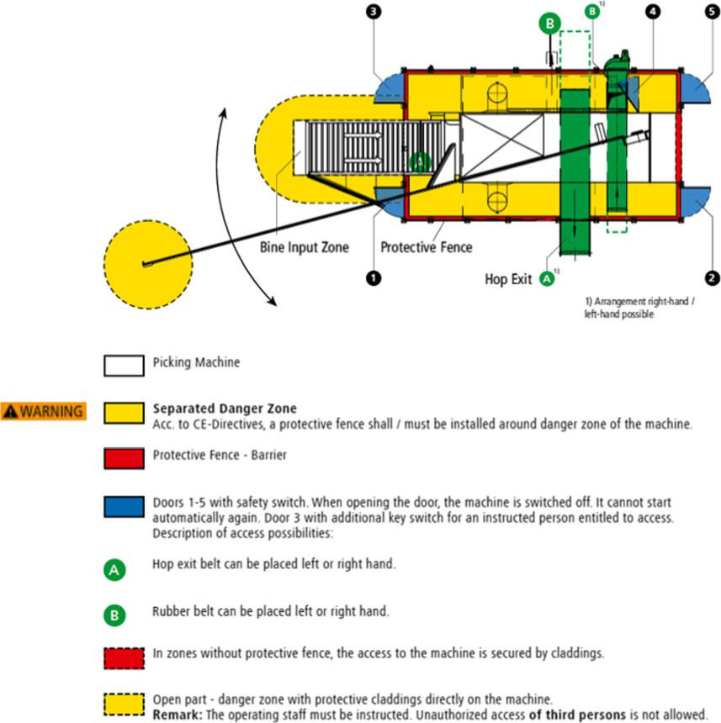

Fig. 2. Technical drawing of safety areas to observe around the hop-picking machine (Operation and Maintenance Manual of WHE 500). https://www.wolf-geisenfeld.de/en/harvesting-technology/whe-picking-machine
machine that points out the danger zones and where to install protective fences. The principal risks reported and highlighted by safety signs are gear entanglement, crushing hazard (due to suspended loads) and slipping and stumbling in the shed environment. Entering is allowed only with PPE as helmets, glasses, ear protectors, gloves, safety clothes etc.
Table 1 shows the health and safety risks and standard references for risk assessment for both manual and mechanical hop harvesting activities.

Table. 1. Summary table of health and safety risks in different hop-picking modalities and standards referred to for risk assessment.
Harvest method | Factor | Risk | Reference
Manual hop picking | Working at height | Falls from ladder or elevator | ISO 45001:2018
 |  |  | SOP for Working on Height Hazards
 | Repetitiveness | Biomechanical  overload | ISO 11228-3 2009: “Handling of low  loads at high frequency”
 |  |  | The OCRA index
 | Awkward  postures | Pain, fatigue  and MSDs | ISO 11226: 2019 “Evaluation of Static  Working Postures”
LUBA-OWAS index: posture-related
load and handling
Mechanized  hop picking | Human–  machine  interaction | Gear  entanglement | ISO 12100:2010 Safety of machinery-  general principles for design-Risk  assessment and risk reduction
 | Suspended  loads | Crushing  hazard | Machinery ‘s operation and  maintenance manual
 | Work shed  environment | Slipping and  stumbling

4 Conclusion
This paper has highlighted different critical health and safety risks issues during hop harvesting depending on various harvest methods. Regarding manual harvest, the principal hazard is attributed to uncomfortable work conditions taking unpleasant positions, repetitiveness and duration of activities. Instead, during the mechanized harvesting operations, the risks are mainly attributed to a dangerous environment due to specific features of the machine. Although adopting barriers and devices to secure harvesting machine is crucial to reduce risks, the human factor is essential to prevent incorrect use. In [25] reported empirical evidence that operator’s manuals are infrequently read, and warnings reported on them are scarcely noticed. This gives the importance of the operator’s manual as a source of information for machine safe operation and maintenance [25]. In [26], additionally, emphasized the limited efficacy of the operator’s manual in conveying safety information, stressing the need to revise this instrument to achieve better readability.

Despite the mechanized harvesting equipment can represent a safety risk for the operators, if the safety guidelines established by the manufacturer are observed and if the PPE is properly worn, safety hazards in the working environment are reduced. Thus, mechanized operations lead to an improvement in workers’ health conditions. Moreover, although small farms have difficulties making investments to mechanize the harvesting operations, this results in advantage not only for occupational health but also for the production efficiency [27, 28].

Further work needs to be carried out to assess the gravity of risks and define recommendations and precautions required to reduce risks. Under the ISO 11226:2019 and ISO 11228-3:2009, detailed risk assessment could provide crucial information on the operators working conditions and help identify possible solutions to risk reduction. Therefore, the hop-picking machine must be designed following provisions from ISO 12100:2010, to guarantee worker safety. Moreover, the employment of high trained operators and the compliance of safety guidelines specified by the manufacturer will reduce work-related injuries.

References
- Food and Agriculture Organization of the United Nations (2018) FAOSTAT Statistical Database, Rome, FAO.
- Cabras I, Higgins D, Preece D (2016) Brewing, beer and pubs: a global perspective. 1st edn. Springer, London, United Kingdom.
- Gargani E, Faggioli F, Haegi A (2018) A survey on pests and diseases of Italian Hop crops. Italus Hortus 24(24):1–17.
- Bailey B, Schönberger C, Drexler G, Gahr A, Newman R, Pöschl M, Geiger E (2009) The influence of hop harvest date on flavor stability in dry-hopped beers. Technical Quarterly of the Master Brewers Association of the Americas 46(2):1–7.
- Lafontaine S, Varnum S, Roland A, Delpech S, Dagan L, Vollmer D, Kishimoto T, Shellhammer T (2019) Impact of harvest maturity on the aroma characteristics and chemistry of Cascade hops used for dry-hopping. Food Chemistry 278:228–239.
- Micheletti CM, Giustetto A, Caffaro F, Colantoni A, Cavallo E, Grigolato S (2019) Risk assessment for musculoskeletal disorders in forestry: a comparison between RULA and REBA in the manual feeding of a wood-chipper. International Journal of Environmental Research and Public Health 16(5):793.
- Naeini HS, Karuppiah K, Tamrin SB, Dala K (2014) Ergonomics in agriculture: an approach in prevention of Work-related Musculoskeletal Disorders (WMSDs). Journal of Agriculture and Environmental Sciences 3(2):33–51.
- Lundqvist P, Gustafsson B (1992) Accidents and accident prevention in agriculture A review of selected studies. International Journal of Industrial Ergonomics 10(4):311–319.
- Lizotte E (2015) The Art and Science of Hop Harvest. Michigan State University Extension, Michigan, USA.
- Campbell SM, Pearson BJ (2019) Harvest techniques for hops (Humulus lupulus). EDIS 2019(6):4.
- Sirrine JR, Rothwell NL, Goldy RG, Marquie S, Brown-Rytlewski D (2010) Sustainable hop production in the Great Lakes region. Michigan State University Extension, Michigan, USA.
- Kumhála F, Kavka M, Prošek V (2013) Capacitive throughput unit applied to stationary hop picking machine. Computers and Electronics in Agriculture 95:92–97.
- Zbynek A (1987) Method and equipment for harvesting hop vines. European Patent Office (Agrozet Koncern Zemedelskeho Strojirenstvi).
- Daniel K, Charron EJ (2020) Hop picking machine. United States Patent (Dk Fab Inc).
- Assirelli A, Carbone K, Ciccoritti R (2020) Mechanical hop-picking solutions in Italian cultivated areas. Sustainability 12(12):1–13.
- Caffaro F, Micheletti Cremasco M, Roccato M, Cavallo E (2017) It does not occur by chance: a mediation model of the influence of workers’ characteristics, work environment factors, and near misses on agricultural machinery-related accidents. International Journal of Occupational and Environmental Health 23(1):52–59.
- Arcangeli G, Traversini V, Tomasini E, Baldassarre A, Lecca LI, Galea RP, Mucci N (2020) Allergic anaphylactic risk in farming activities: a systematic review. International Journal of Environmental Research and Public Health 17(14):4921.
- Reeb-Whitaker CK, Bonauto DK (2014) Respiratory disease associated with occupational inhalation to hop (Humulus lupulus) during harvest and processing. Annals of Allergy Asthma & Immunology 113(5):534–538.
- ISO 11226 (2019) Evaluation of Static Working Postures, International Organization for Standardization, Geneva, Switzerland.
- Delleman NJ, Dul J (2007) International standards on working postures and movements ISO 11226 and EN 1005-4. Ergonomics 50(11):1809–1819.
- ISO 11228-3 (2009) Handling of low loads at high frequency, International Organization for Standardization, Geneva, Switzerland.
- Lavatelli I, Schaub K, Caragnano G (2012) Correlations in between EAWS and OCRA Index concerning the repetitive loads of the upper limbs in automobile manufacturing industries. Work 41(1):4436–4444.
- ISO 45001 (2018) Occupational health and safety management systems-Requirements with guidance for use, International Organization for Standardization, Geneva, Switzerland.
- ISO 12100 (2010) Safety of machinery–General principles for design–Risk assessment and risk reduction, International Organization for Standardization, Geneva, Switzerland.
- Tebeaux E (2010) Safety warnings in tractor operation manuals, 1920–1980: manuals and warnings don’t always work. Journal of Technical Writing and Communication 40(1):3–28.
- Tebeaux E (2010) Improving tractor safety warnings: readability is missing. Journal of Agricultural Safety and Health 16(3):181–205.
- Callahan C (2014) Harvest and beyond harvesters, Drying Oasts, and Pelletizing.
- Neve RA (1991) Hops. 1st edn. Springer-Science+Business Media, B.V. Netherlands.

